**Phase 2: Org Setup & Configuration (Food Waste Tracking CRM)**

**Step 1: Salesforce Edition**

1. Go to **developer.salesforce.com**.
2. Sign up for a **Free Developer Org** (activation email will be sent).
3. A screenshot of a computer

   AI-generated content may be incorrect.Log in and confirm **Lightning Experience** is enabled (top right gear → check if Lightning is active).

**Step 2: Company Profile Setup**

1. Click **⚙️ Setup → Company Information**.
2. Click **Edit** and set:
   * Company Name: Food Waste Tracking CRM
   * Default Time Zone: Asia/Kolkata (IST)
   * Locale: English (India)
   * Currency: INR
3. Save.

**Step 3: Business Hours & Holidays**

1. In Setup, search **Business Hours**.
   * Name: Food Donation Operations
   * Hours: 9:00 AM – 9:00 PM

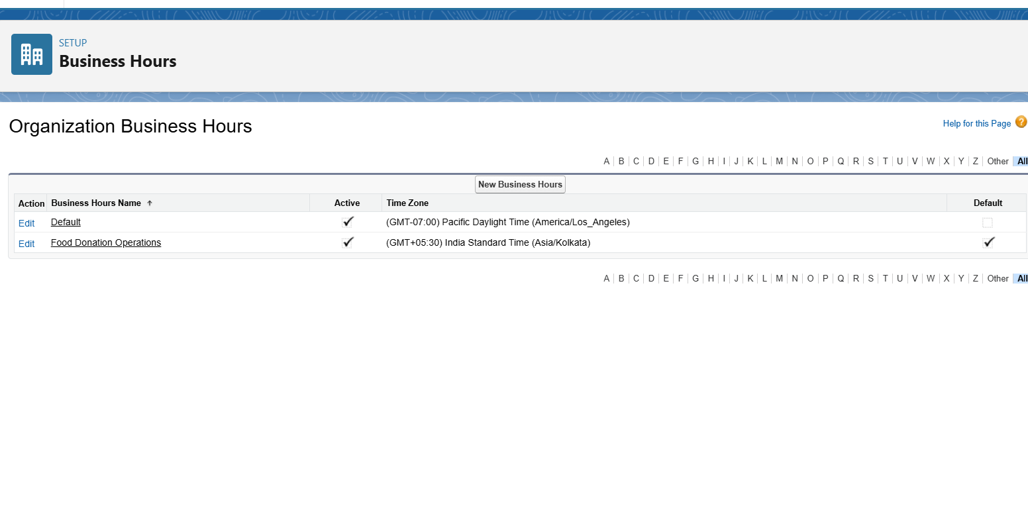

1. In Setup, search **Holidays**.
   * Add at least 2 holidays (e.g., Republic Day 26-Jan, Diwali date).
   * Check **All-Day Event**.
   * For repeating holidays (e.g., Independence Day), select **Recurring Holiday**.

**Step 4: Fiscal Year Settings**

1. In Setup, search **Fiscal Year**.
2. Keep **Standard Fiscal Year (Jan–Dec)**.
   * Start Month: January
   * Fiscal Year Name: 2025 (for Jan–Dec 2025).

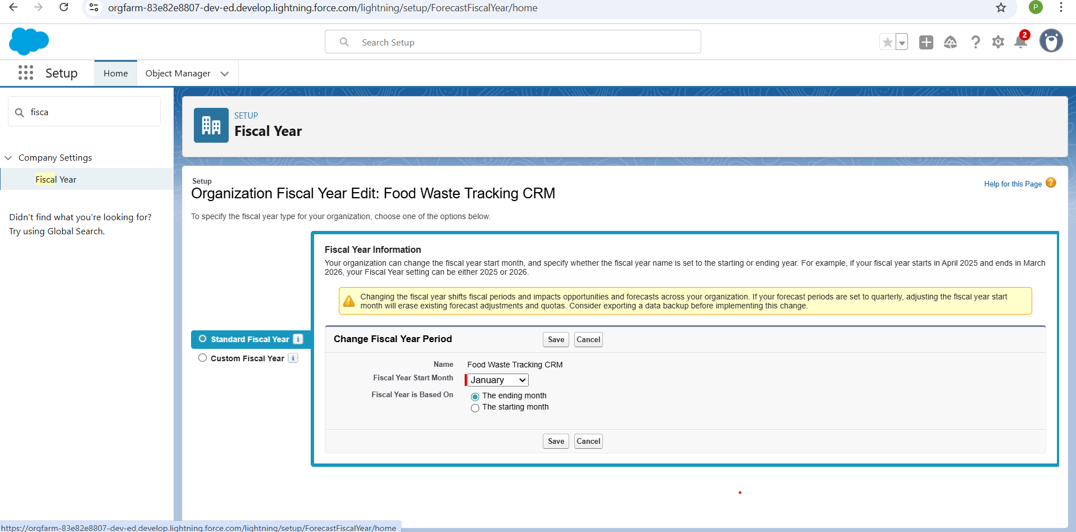

**Step 5: User Setup & Licenses**

1. Setup → **Users → Users → New User**.
2. Create:
   * **Admin User** – License: Salesforce, Profile: System Administrator.
   * **Donor User** – License: Salesforce/Platform, Profile: Standard User.
   * **NGO User** – License: Salesforce/Platform, Profile: Standard User.
   * **Reviewer User** – License: Salesforce, Profile: Read Only.
3. Use unique usernames (email-style, e.g., donor.crm2025@gmail.com).

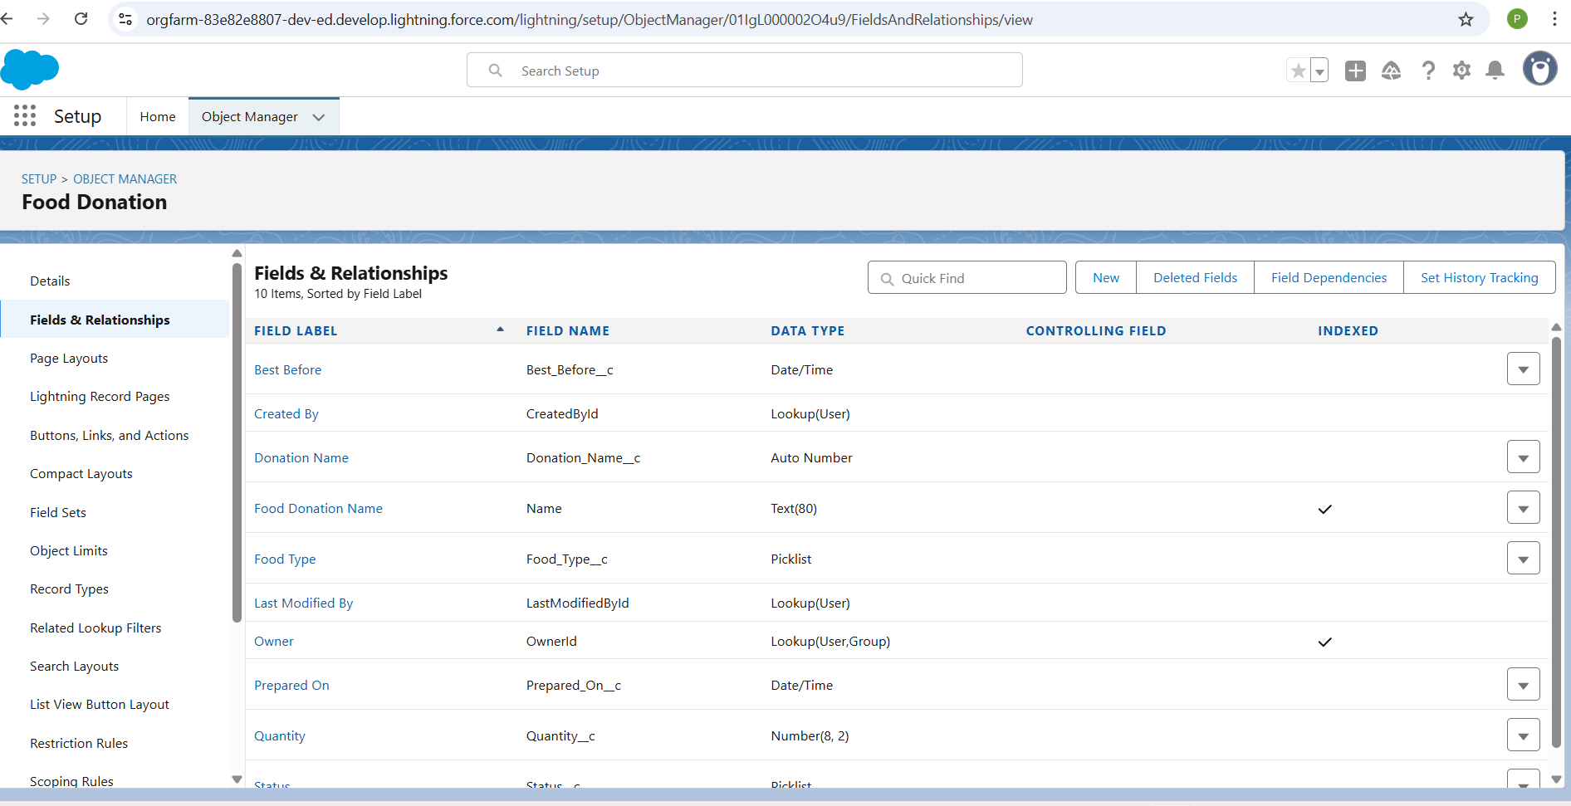

**Step 6: Profiles**

1. Setup → **Profiles**.
2. Clone Standard User → Name Donor Profile.
   * Permissions: Create/Read **Food Donation**. No delete.

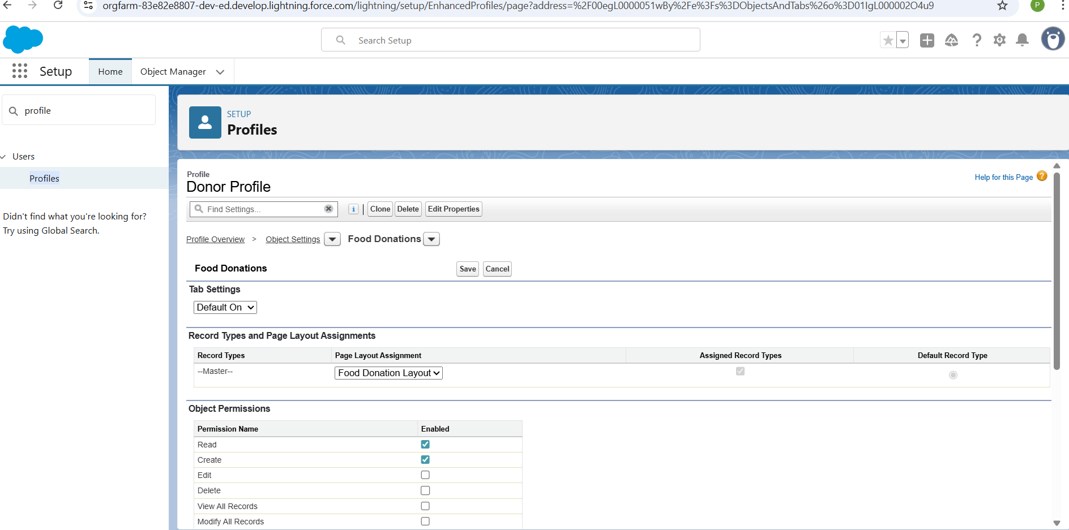

1. Clone Standard User → Name NGO Profile.
   * Permissions: Read/Update assigned **Food Donation** + **Pickup Request**.

1. Admins → keep **System Administrator Profile** (full access).

**Step 7: Roles**

1. Setup → **Roles → Set Up Roles**.
2. Create hierarchy:
   * Top: System Admin
   * Middle: NGO Coordinator
   * Bottom: Donor

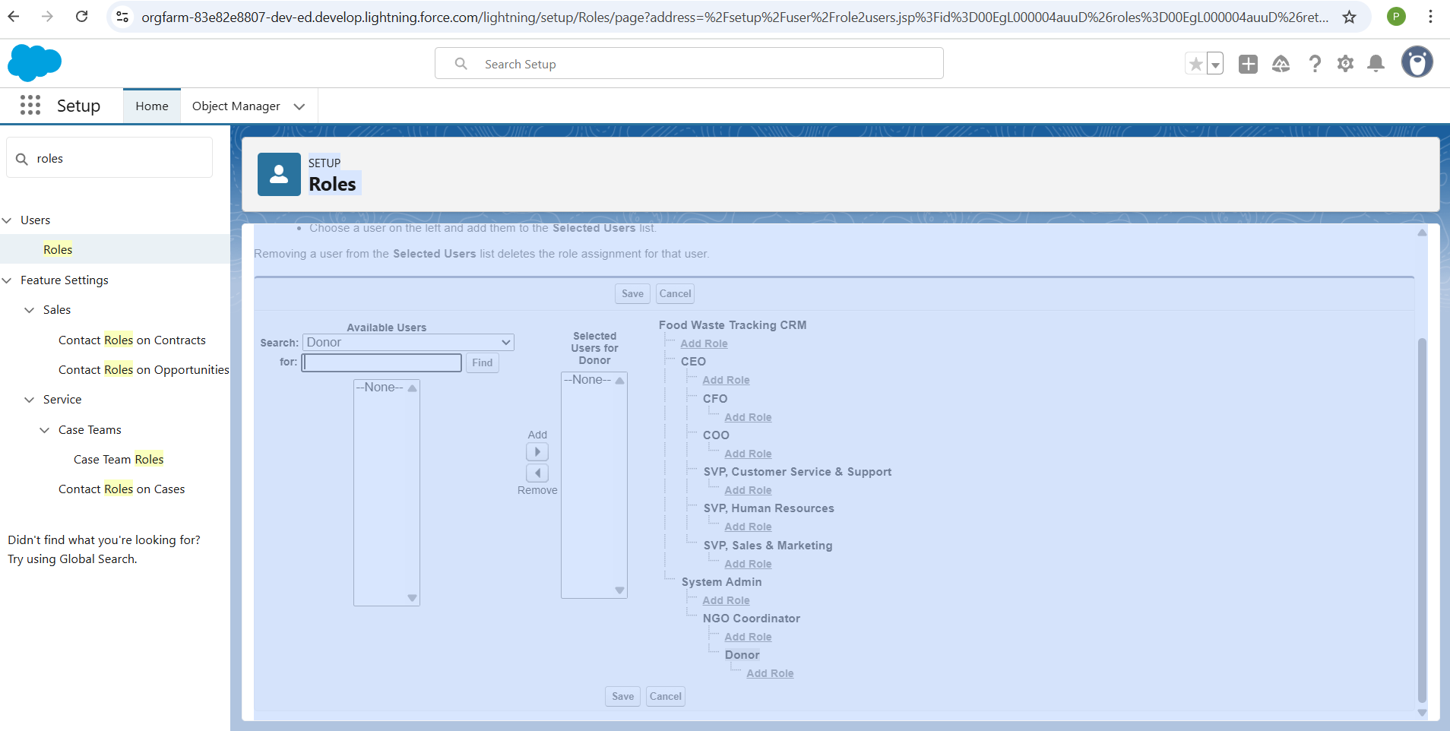

1. Assign users to roles.
   * Donors under Donor role.
   * NGOs under NGO Coordinator role.

**Step 8: Permission Sets**

1. Setup → **Permission Sets → New**.
   * Name: Reports Access.
   * Add permissions: Run Reports, View Dashboards, Create Dashboards.
2. Assign this set to NGO and Admin users.

**Step 9: Organization-Wide Defaults (OWD)**

1. Setup → **Sharing Settings**.
2. Set defaults:
   * **Food Donation** → Private.
   * **Pickup Request** → Controlled by Parent.
   * **Donor** → Private.
   * **NGO** → Public Read-Only.
3. Save.

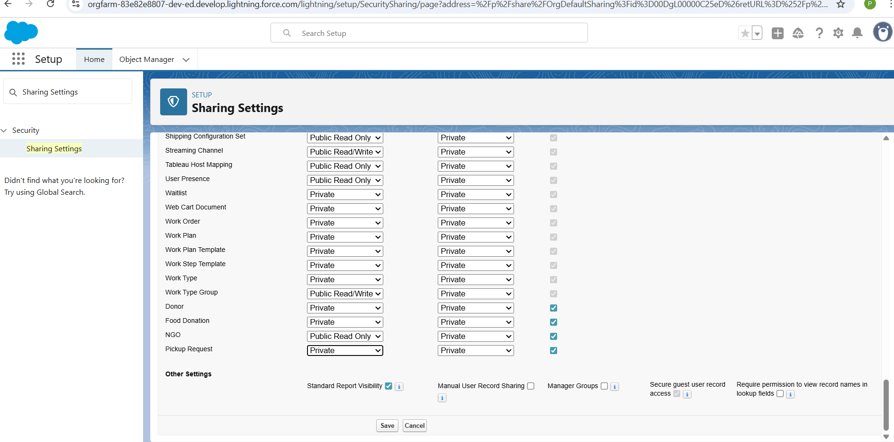

**Step 10: Sharing Rules**

1. In **Sharing Settings**, scroll to **Food Donation Sharing Rules**.
2. Create new rule:
   * Label: Share Donations with NGO.
   * Based on criteria: Assigned NGO field is not blank.
   * Share with: Role = NGO Coordinator.
   * Access: Read/Write.

**Step 11: Login Access Policies**

1. Setup → **Profiles → Donor Profile → Edit**.
2. Under **Login Hours**:
   * Allow access only 9:00 AM – 9:00 PM.
3. Save.

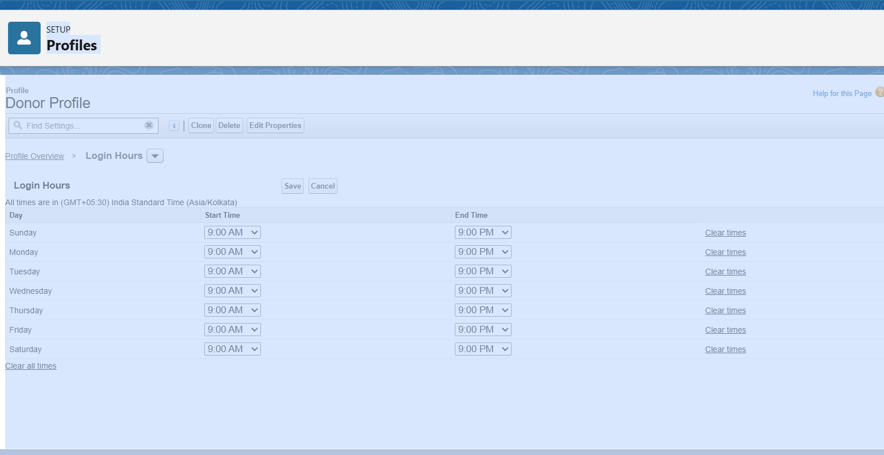

**Step 12: Developer Org Setup**

* Your **Developer Edition** org acts as a sandbox for this project.
* Confirm at the top: Food Waste Tracking CRM (Developer Edition).

**Step 13: Deployment Basics**

* In real projects:
  + **Change Sets** → For moving metadata from Sandbox to Production.
  + **Salesforce CLI (SFDX)** → For advanced deployments.